**MACHINE LEARNING PROBLEM SET-4**

**1 EMPIRICAL PROBLEMS**

(e)

|  |  |  |
| --- | --- | --- |
|  | **MODEL** | **MSEs** |
| **SPEC 1** | Neural Net | 0.05164688 |
| Poly | 0.05233071 |
| RF | 0.09330446 |
| **SPEC 2** | Neural Net | 0.36291110 |
| Poly | 0.14700650 |
| RF | 0.12740863 |

(f) Based on the MSEs for the two specifications:

For **Specification 1**, the Neural Net and Polynomial Regression (Poly) models performed similarly, both with low MSEs around 0.05, indicating good predictive accuracy. The Random Forest (RF) model had a higher MSE of 0.093, suggesting it did not perform as well as the other models.

For **Specification 2**, the RF model showed the best performance with the lowest MSE of 0.127, followed by the Poly model at 0.147. The Neural Net had a significantly higher MSE of 0.363, indicating it struggled with this more complex specification.

**Observation**: Neural Networks might perform better with simpler relationships (Specification 1), while Random Forests can handle complex interactions (Specification 2) more effectively due to their non-parametric nature.

**2**

(a)

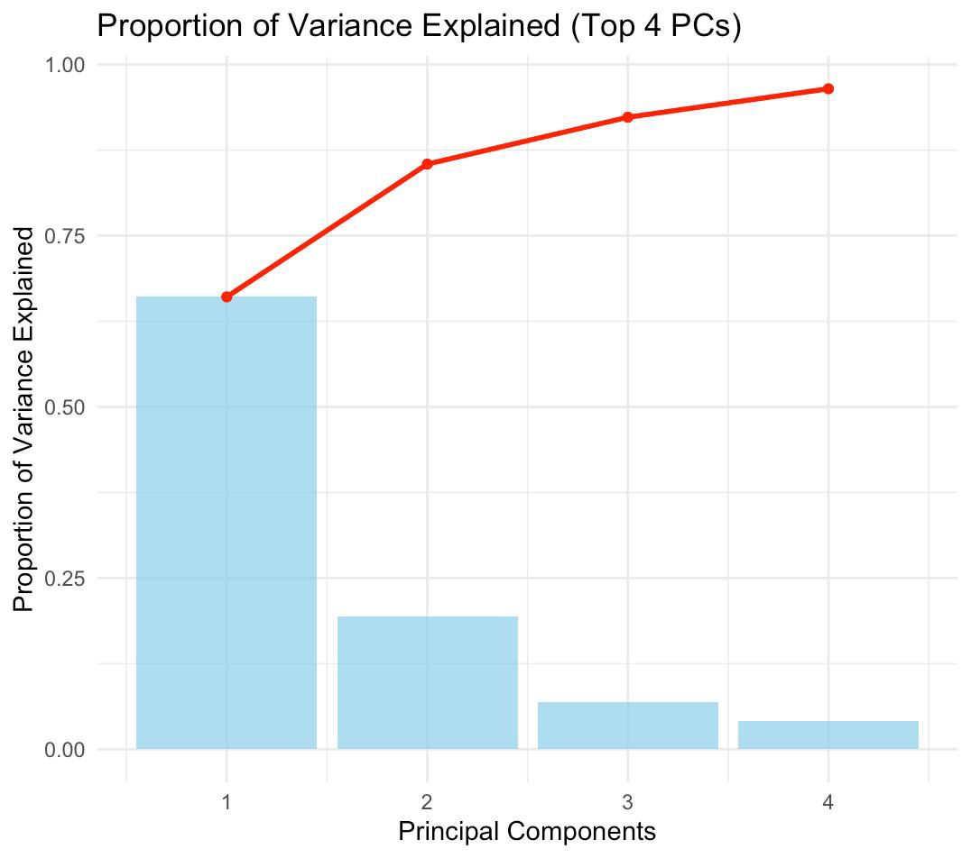

(d)

|  |  |
| --- | --- |
| **MODEL** | **TEST MSE** |
| PCA Model | 14010.57 |
| Random Forest Model | 11305.42 |
| Second Order Poly Model | 12685.32 |
| Lasso Model | 12925.66 |
| Ridge Model | 12815.47 |

**Observations:**

1. *Random Forest (RF)* has the lowest Test MSE (11305.42), indicating it provides the best predictive performance among the models. This suggests RF captures complex non-linear relationships and interactions effectively.

2. *Polynomial Regression (POLY), Ridge, and Lasso* have similar Test MSE values (12685.32, 12925.66, and 12815.47, respectively). This indicates these models perform comparably, though RF still outperforms them.

3. *Principal Component Regression (PCR)* has the highest Test MSE (14010.57), suggesting that the dimensionality reduction approach might not be capturing enough variability in the predictors to make accurate predictions.

4. The relatively small differences between the models (except PCR) suggest that while RF is the best choice, the other methods are reasonable alternatives depending on the specific context or constraints (e.g., interpretability, computational cost).

(e) **Steps for Model Averaging:**

1. **Assign Weights Based on Performance**:

Calculate weights inversely proportional to the Test MSE for each model:

$$w_i = (1 / MSE_i) / Σ (1 / MSE_j)$$

Here, $w_i$ ​ is the weight for model iii, and $MSE_i​$ is the Test MSE for that model. This gives higher weights to models with lower MSE.

1. **Combine Predictions**:

Compute the ensemble prediction as a weighted average of individual model predictions:

$$y_ensemble = Σ (w_i * y_i)$$

Where $y_i$ ​ is the prediction from model $i$, and $w_i$ ​ is its corresponding weight.

1. **Evaluate Ensemble Performance**:

Calculate the Test MSE for the ensemble predictions to check if model averaging improves performance.

**Relative Contribution of Models:**

* **Random Forest (RF)**:  
  RF will have the *highest weight* in the ensemble due to its lowest Test MSE, making it the dominant contributor.
* **Polynomial Regression, Ridge, and Lasso**:  
  These models will contribute moderately as their Test MSE values are relatively close but higher than RF.
* **Principal Component Regression (PCR)**:  
  PCR will have the *smallest weight* due to its poor performance (highest Test MSE). Its contribution to the ensemble will likely be negligible.

By combining models, the ensemble is expected to leverage the strengths of multiple approaches, particularly RF, to achieve better predictive performance than any single model alone.